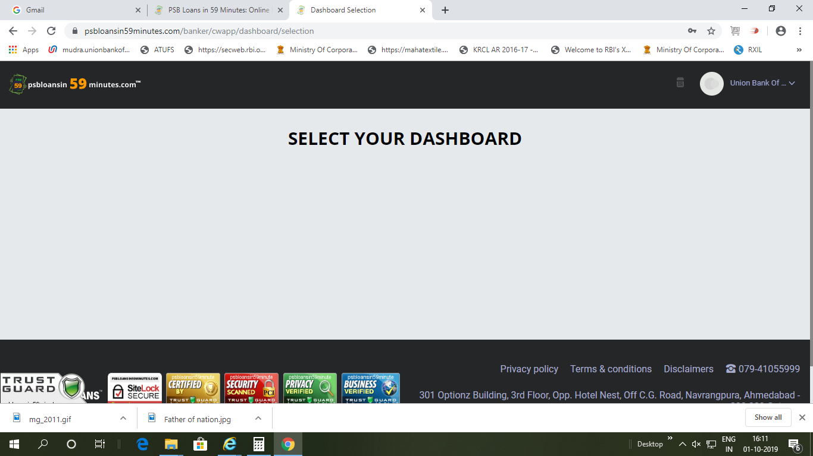

Nothing is displayed after Branch Login